## **Introduction of Project and Data Overview.**

**Table 1. Data overview**

|  |  |  |  |  |  |
| --- | --- | --- | --- | --- | --- |
| *E(GPa)* | *f'c (MPa)* | *Pmax (N)Avg* | *KsIC (MPa)* | *CTODC (mm)* | *final_crack* |
| *45.2* | *65.1* | *1882.4219* | *0.8402* | *0.0224* | *0.0532* |
| *35.5* | *67.5* | *7350* | *0.6747* | *0.005* | *0.0074* |
| *37.89* | *87.71* | *4150* | *7.941* | *0.321* | *0.0137* |
| *45.2* | *65.1* | *1864.4219* | *0.6769* | *0.0155* | *0.0473* |
| *42.987* | *122.52* | *10300* | *11.103* | *0.172* | *0.0213* |
| *35.5* | *67.5* | *12516.6667* | *1.0402* | *0.0166* | *0.0323* |
| *35.5* | *67.5* | *7350* | *0.813* | *0.0083* | *0.0136* |
| *35.5* | *67.5* | *7350* | *0.6859* | *0.0015* | *0.0007* |
| *35.5* | *67.5* | *7350* | *0.9588* | *0.0127* | *0.0212* |
| *42.987* | *122.52* | *10620* | *11.892* | *0.383* | *0.0085* |

*The final Crack is different between the critical concrete crack and initial concrete crack from the lab report.*

## **Explanatory Descriptive Analysis and Variables Visualization**

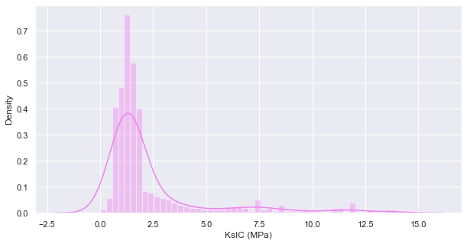

**Fig 1.** *For the target variable KsIC (Mpa) the median is 1.438882, the mean is 2.340661, and the maximum is 13.9840. This indicates that the distribution is skewed to the right. The histogram above confirms this*

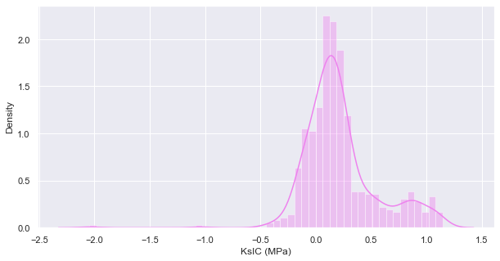

**Fig 1.1** *After transformation, our becomes normally distributed, Good for prediction*

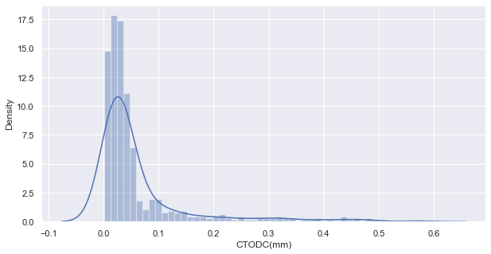

**Fig 2.** *For the target variable CTODC (mm) the median is 0.030306the mean is 0.061158, and the maximum is 0.581000. This indicates that the distribution is skewed to the right. The above histogram confirms this.*

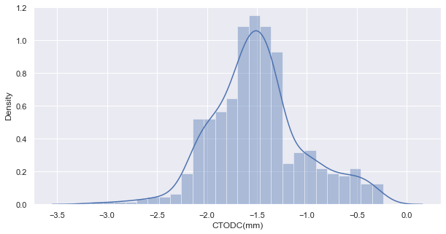

**Fig 2.1** *After transformation, our becomes normally distributed. Good for prediction*

**Table 2. Grouped the Average of Kisc and CTOD by the compressive strength**

|  |  |  |
| --- | --- | --- |
|  | KiSC (Mpa) | CTOD(mm) |
| f’c (Mpa) |  |  |
| 42.20 | 0.503704 | 0.007204 |
| 57.14 | 1.076716 | 0.041500 |
| 65.10 | 0.730065 | 0.018157 |
| 67.50 | 1.006791 | 0.014659 |
| 87.71 | 7.171118 | 0.227559 |
| 122.52 | 11.089160 | 0.270176 |

*The table show that as the KiSC and CTOD relatively increases as the compressive strength increase*

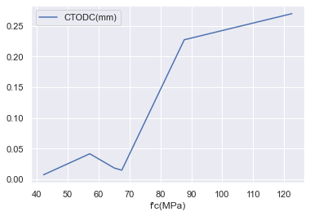

**Fig 3**. *The graph shows the relationship between the compressive strength and CTOD, giving a visual increase in compressive strength with increase in the CTOD*

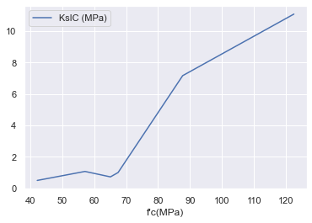

**Fig 4**. *The graph shows the relationship between the compressive strength and KiSC, giving a visual increase in compressive strength with increase in the KiSC*

**Table 3. Grouped the Average of Kisc and CTOD by Maximum and Minimum Peak load**

|  |  |  |
| --- | --- | --- |
|  | *KsIC (MPa)* | *CTODC (mm)* |
| *Pmax (N)Avg* |  |  |
| *19490* | *13.9840* | *0.5810* |
| *19310* | *13.8010* | *0.5630* |
| *14230* | *13.5410* | *0.4830* |
| *13980* | *13.5820* | *0.4900* |
| *13510* | *12* | *0.3010* |
| *13370* | *12.0130* | *0.3069* |
| *12517* | *0.9952* | *0.0148* |
| *10850* | *11.9490* | *0.3898* |
| *10620* | *11.8920* | *0.3830* |
| *10300* | *11.1030* | *0.1720* |
| *10120* | *11.3210* | *0.1810* |
| *10010* | *12.6520* | *0.4400* |

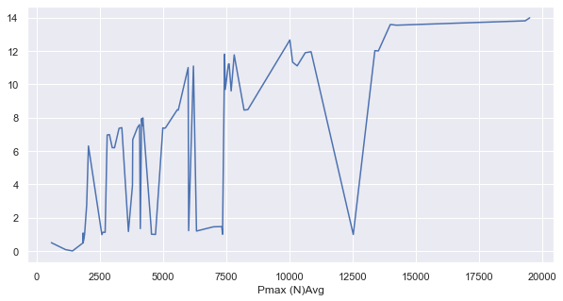**Fig 5**. *The graph shows the relationship between the peak load and KiSC, giving a visual increase in peak load with increase in the KiSC*

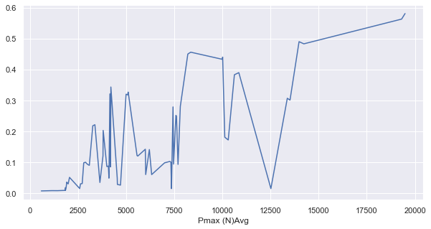

**Fig 6**. *The graph shows the relationship between the peak load and CTOD, giving a visual increase in peak load with increase in the CTOD*

**Table 4. Grouped the Average of Kisc and CTOD by** **Elastic Modulus**



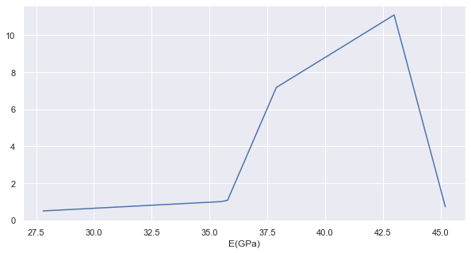

**Fig 7**. *The graph shows the relationship between the Elastic Modulus and KiSC, giving a visual increase in Elastic Modulus with increase in the KiSC*

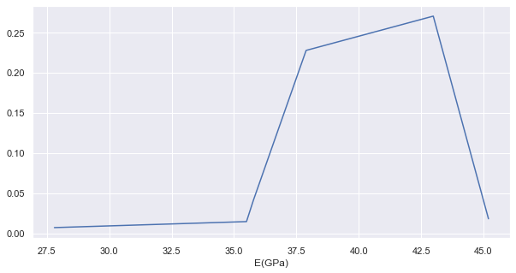

**Fig 8**. *The graph shows the relationship between the Elastic Modulus and CTOD, giving a visual increase in Elastic Modulus with increase in the CTOD*

## Discuss Interaction and select for model

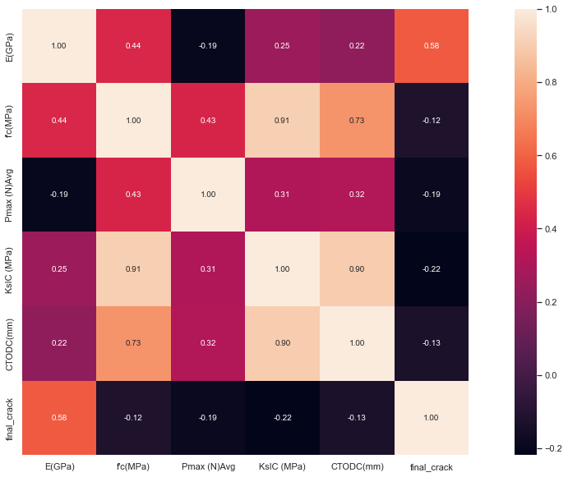

**Fig 9.** *The group measure of relationship the target variable and other independent variable. KiSC has high correlation with the compressive strength, elastic modulus and peak load than the CTOD. The CTOD and KiSC has negative correlation with the final crack, which means the difference between the final and initial decreases as the CTOD and KiSC increases.*

*Based on the missing data present and outlier, the interaction is obvious as the concrete stress intensity factor depends on the compressive strength of concrete based on the mixture. The concrete can take more load if the compressive strength is relatively high*

## Task 7 – Validate the model

A linear regression model built to predict the KiSC and CTODC based on the interaction selected

Table 5.

|  |  |  |
| --- | --- | --- |
| Features | Weight of CTOD | Weight of KiSC |
| Pmax (N)Avg | -3.397678 | -67.327838 |
| f’c (MPa) * Pmax (N)Avg | -0.6695 | -15.994099 |
| E(GPa) * f’c (MPa) | -0.6151 | -8.350571 |
| final_crack | -0.3361 | -8.097447 |
| f'c (MPa) * final_crack | -0.2616 | -3.541733 |
| Pmax (N)Avg * final_crack | 0.0893 | 2.097477 |
| E(GPa) | 0.1066 | -1.545047 |
| f'c (MPa) | 0.1287 | 2.151581 |
| E(GPa) * final_crack | 0.5832 | 11.090585 |
| E(GPa) * Pmax (N)Avg | 3.5715 | 72.793236 |

The R-squared of 0.852 reveals that 85.2% of the variability observed in the target variables, CTOD and KiSC, are explained by the regression model with a model Mean square error of 0.205

AIC: -471.153

## Task 9 – Investigate Ridge regressions

Table 6. Ridge regression

|  |  |  |
| --- | --- | --- |
| Features | Weight of CTOD | Weight of KiSC |
| Pmax (N)Avg | -0.152388 | -3.077661 |
| f’c (MPa) * Pmax (N)Avg | -0.1047 | -0.543021 |
| E(GPa) * f’c (MPa) | -0.0509 | -1.202151 |
| final_crack | -0.0477 | -1.119517 |
| f'c (MPa) * final_crack | -0.0152 | 0.304648 |
| Pmax (N)Avg * final_crack | 0.0075 | 0.035612 |
| E(GPa) | 0.0225 | 0.424592 |
| f'c (MPa) | 0.0512 | -0.649255 |
| E(GPa) * final_crack | 0.0679 | 1.032182 |
| E(GPa) * Pmax (N)Avg | 0.1884 | 3.067131 |

The R-squared of 0.873 reveals that 87.3% of the variability observed in the target variables, CTOD and KiSC, are explained by the regression model with a model Mean square error of 0.213

AIC: -459.021